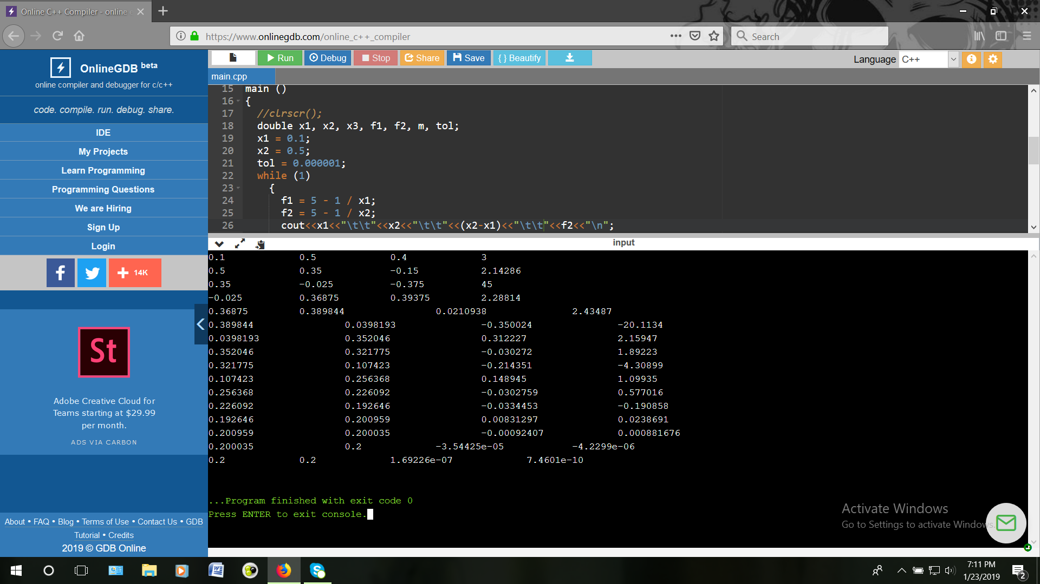

#include <iostream>

using namespace std;

int main ()  
{  
 double x1, x2, x3, f1, f2, m, tol;

x1 = 0.1;

x2 = 0.5;

tol = 0.000001;

while (1)

{

f1 = 5 - 1 / x1;

f2 = 5 - 1 / x2;

cout<<x1<<"\t\t"<<x2<<"\t\t"<<(x2-x1)<<"\t\t"<<f2<<"\n";

m = (f2 - f1) / (x2 - x1);

x3 = x2 - (f2 / m);

if(x2>x1)

{

if((x2-x1)<=tol)

break;

}

else

{

if((x1-x2)<=tol)

break;

}

x1 = x2;

x2 = x3;

}

//getch();

return 0;

}

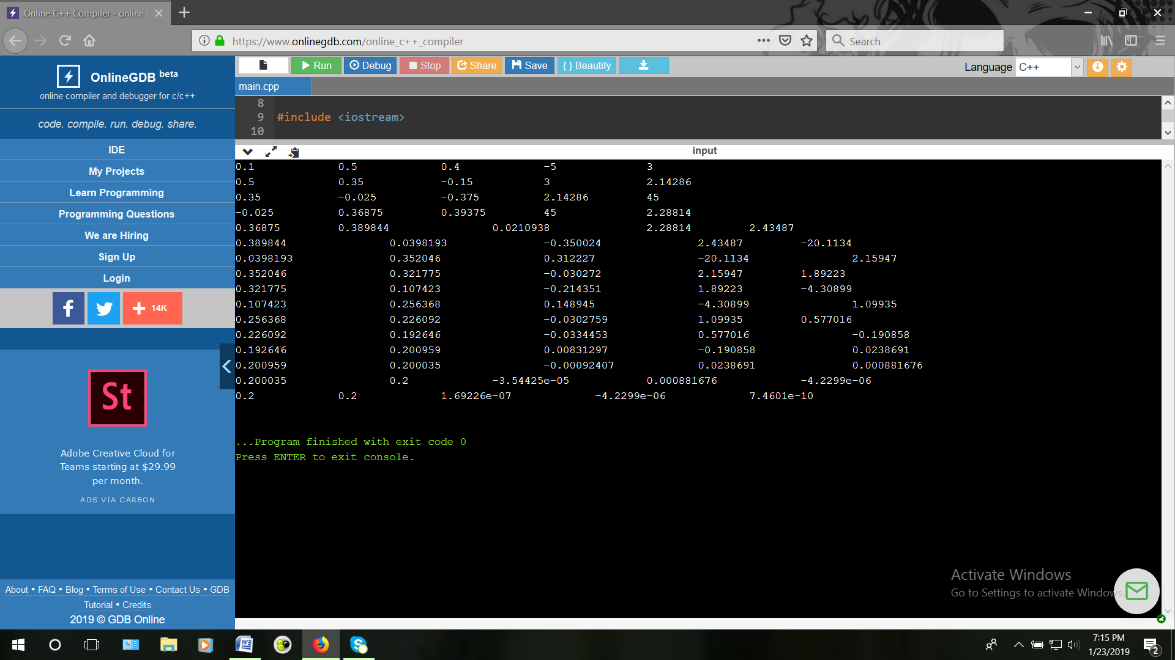

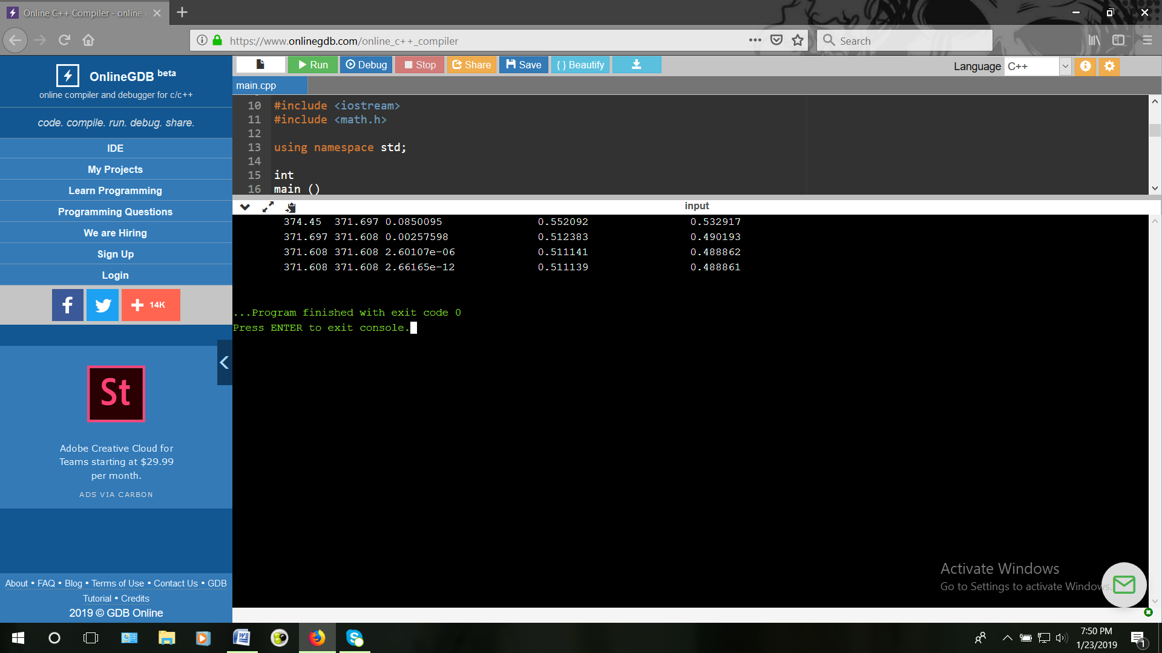

#include <iostream>

#include <math.h>

using namespace std;

int

main ()

{

double t0,t1,f1,f2,a1,a2,b1,b2,c1,c2,y1,y2;

t0=374.450000;

a1=15.9008;

a2=16.0137;

b1=2788.51;

b2=3096.52;

c1=-52.36;

c2=-53.67;

while(1)

{

f1=(((exp(a1-b1/(c1+t0)))\*0.3)+((exp(a2-b2/(c2+t0)))\*0.7))/760.0-1;

f2=((exp(a1-b1/(c1+t0)))\*(0.3\*b1)/((t0+c1)\*(t0+c1))+((exp(a2-b2/(c2+t0)))\*(0.7\*b2)/((t0+c2)\*(t0+c2))))/760.0;

t1=t0-f1/f2;

y1=((exp(a1-b1/(c1+t0)))\*0.3)/760.0;

y2=((exp(a2-b2/(c2+t0)))\*0.7)/760.0;

cout<<"\t"<<t0<<"\t"<<t1<<"\t"<<f1<<"\t\t"<<y1<<"\t\t"<<y2<<"\n";

if((f1<=0.000001)&&(f1>=-0.000001))

break;

t0=t1;

}

return 0;

}

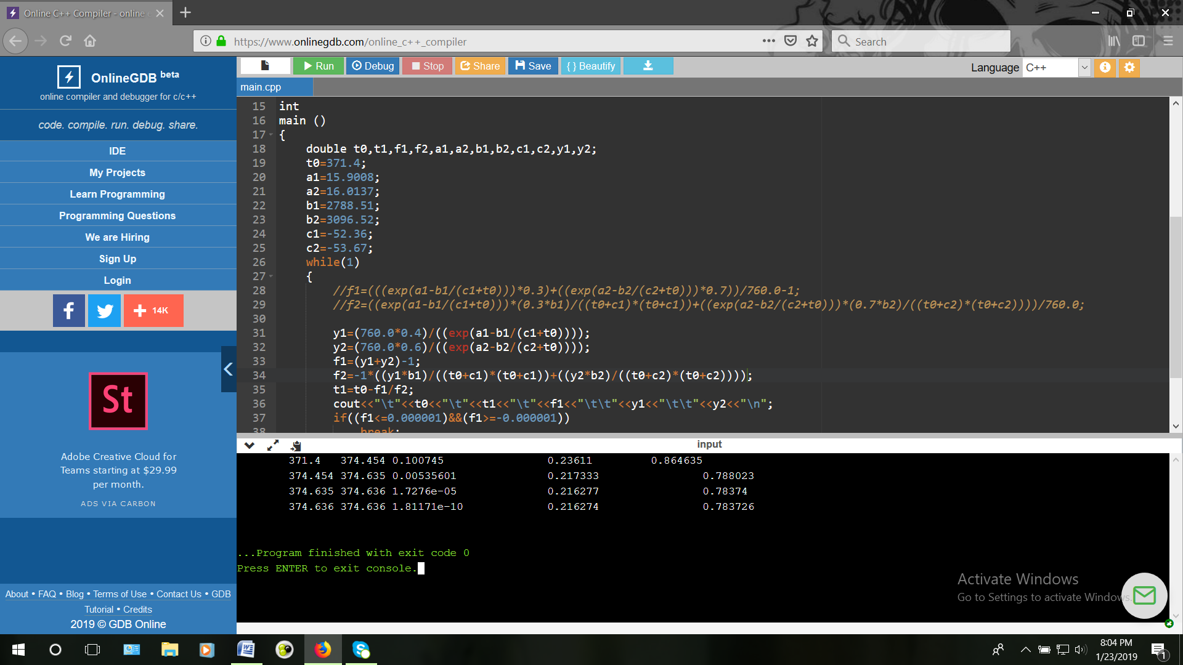

#include <iostream>

#include <math.h>

using namespace std;

int

main ()

{

double t0,t1,f1,f2,a1,a2,b1,b2,c1,c2,y1,y2;

t0=371.4;

a1=15.9008;

a2=16.0137;

b1=2788.51;

b2=3096.52;

c1=-52.36;

c2=-53.67;

while(1)

{

y1=(760.0\*0.4)/((exp(a1-b1/(c1+t0))));

y2=(760.0\*0.6)/((exp(a2-b2/(c2+t0))));

f1=(y1+y2)-1;

f2=-1\*((y1\*b1)/((t0+c1)\*(t0+c1))+((y2\*b2)/((t0+c2)\*(t0+c2))));

t1=t0-f1/f2;

cout<<"\t"<<t0<<"\t"<<t1<<"\t"<<f1<<"\t\t"<<y1<<"\t\t"<<y2<<"\n";

if((f1<=0.000001)&&(f1>=-0.000001))

break;

t0=t1;

}

return 0;

}

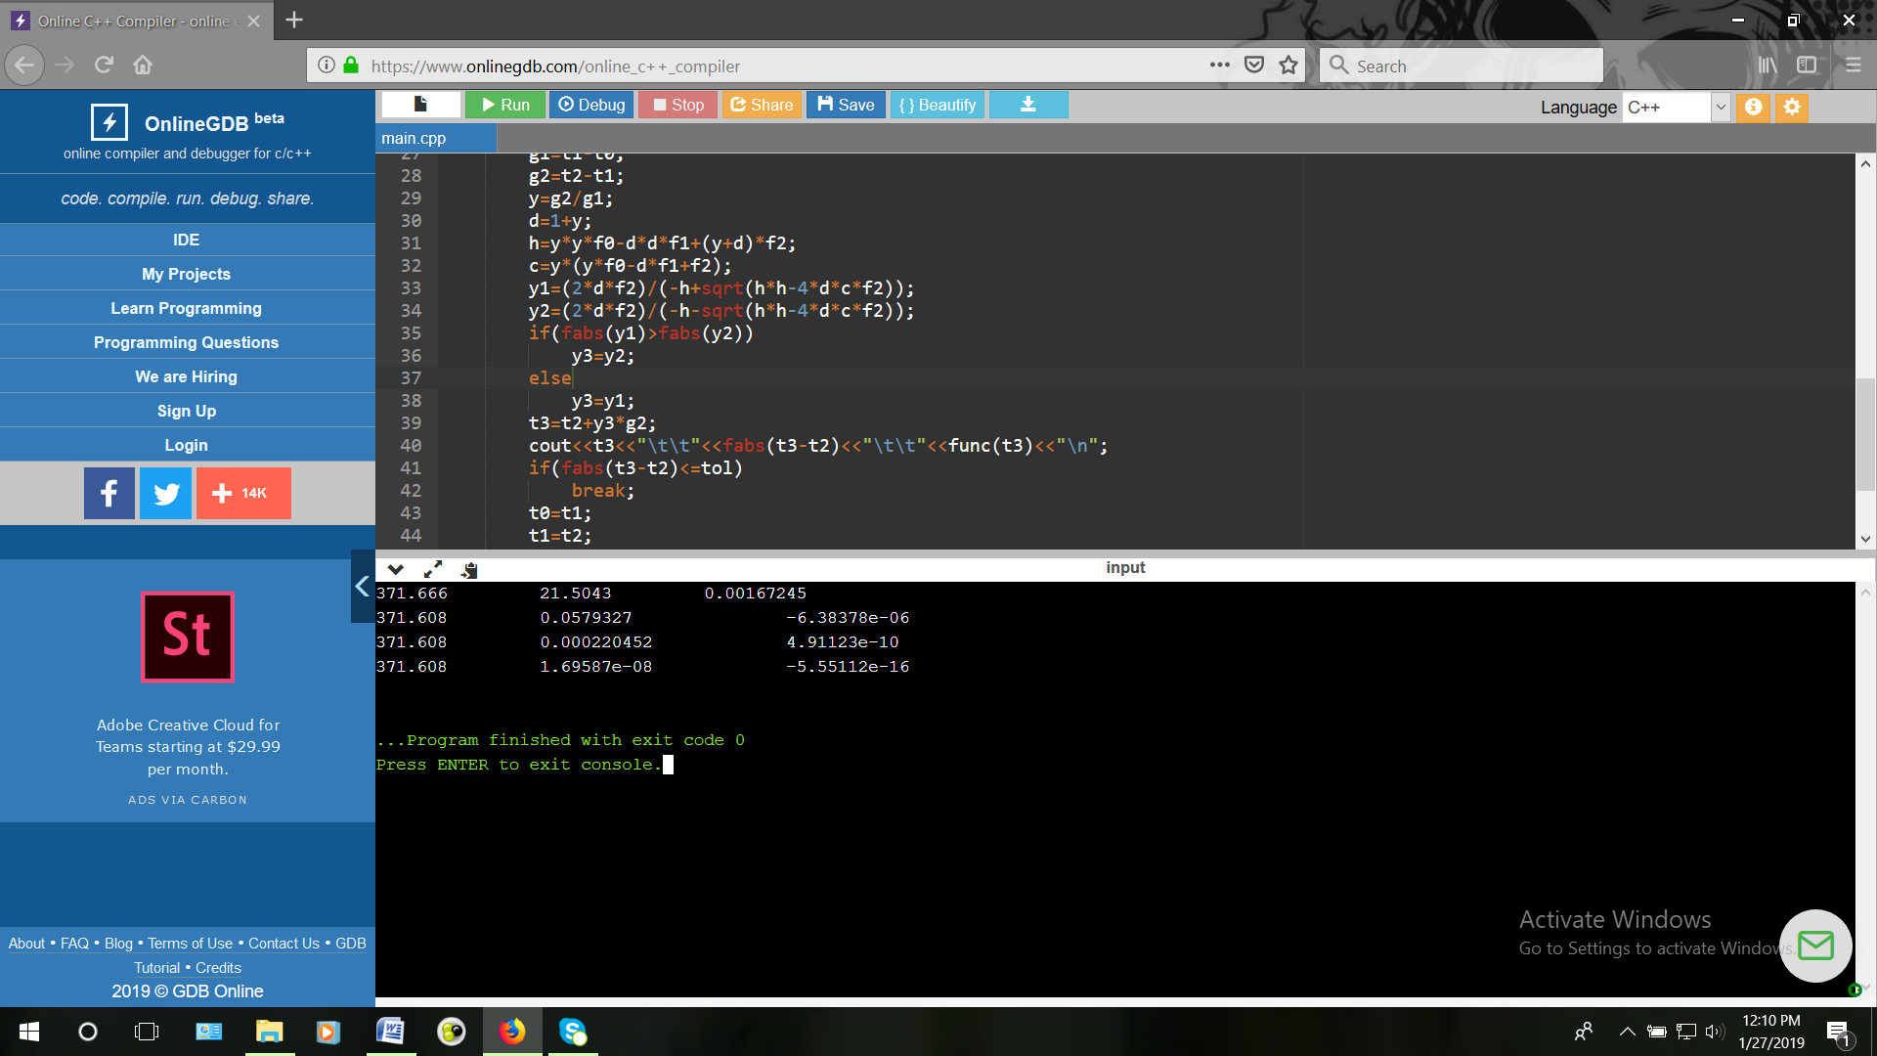

#include <iostream>

#include <math.h>

using namespace std;

double caly1(double x)

{

double f,a1=15.9008,b1=2788.51,c1=-52.36;

f=((exp(a1-b1/(c1+x)))\*0.3)/760.0;

return f;

}

double caly2(double x)

{

double f,a2=16.0137,b2=3096.52,c2=-53.67;

f=((exp(a2-b2/(c2+x)))\*0.7)/760.0;

return f;

}

double func(double x)

{

double f;

f=caly1(x)+caly2(x)-1;

return f;

}

int main()

{

double t0=355.73,t1=374.45,t2=393.17,t3,f0,f1,f2,g1,g2,c,h,d,y,y1,y2,y3,tol=0.000001;

while(1)

{

f0=func(t0);

f1=func(t1);

f2=func(t2);

g1=t1-t0;

g2=t2-t1;

y=g2/g1;

d=1+y;

h=y\*y\*f0-d\*d\*f1+(y+d)\*f2;

c=y\*(y\*f0-d\*f1+f2);

y1=(2\*d\*f2)/(-h+sqrt(h\*h-4\*d\*c\*f2));

y2=(2\*d\*f2)/(-h-sqrt(h\*h-4\*d\*c\*f2));

if(fabs(y1)>fabs(y2))

y3=y2;

else

y3=y1;

t3=t2+y3\*g2;

cout<<t3<<"\t"<<fabs(t3-t2)<<"\t"<<func(t2)<<"\t"<<caly1(t2)<<"\t"<<caly2(t2)<<"\n";

if(fabs(t3-t2)<=tol)

break;

t0=t1;

t1=t2;

t2=t3;

}

return 0;

}

